Rohde & Schwarz  
PA Compression Test  
User manual

February 25, 2016

Table of contents:

1. ZVAX setup
2. Calibrating pulsed RF setup
3. Pulsed RF setup
4. Performing compression measurements
5. Installation
6. Physical setup
7. Measurement channel setup
8. PA Compression Test user interface
   1. Settings tab
   2. Plots tab
   3. Progress screen
   4. Mini user interface mode
9. Performing measurement
10. Plotting
11. Mini user interface mode
12. Data export

# Pulsed RF Measurements

The Rohde & Schwarz ZVAX line of extension units can be used with a ZVA vector network analyzer to perform pulsed RF measurements. This section provides a simple introduction to setting up, calibrating and performing pulsed RF measurements with these extension units.

## ZVAX Extension Unit Setup

Unfortunately, the physical RF setup of the ZVA and the ZVAX extension unit depends largely on your specific measurement requirements. Therefore, in this section we will concentrate on the non-RF part of the setup.

Make sure the ZVAX is turned on. On the rear of the ZVAX you will see two relevant connections:

1. USB FROM NWA - USB type B connector: This should be connected to any available USB type A connector on the ZVA. This connection allows the configuration of the ZVAX to be controlled through the appropriate ZVA menu (see section #).
2. 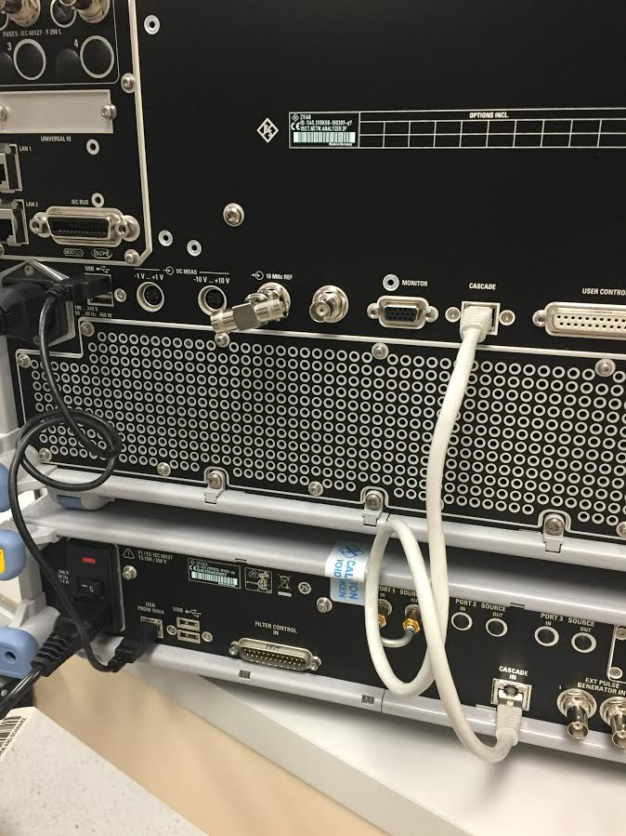 Cascade In: This connection provides timing from the ZVA to ZVAX unit. Specifically, it provides pulsing for the RF modulator switch. The pulse characteristics can be controlled through the ZVA (see section #).

Cascade In

Cascade

USB From NWA

Figure 2: ZVAX to ZVA Connections

## Calibrating Pulsed RF Setup

# Performing compression measurements

Input Power (Pin)

Output Power (Pout)

Gain  
G(f, Pin)

S1

a1

b1

S2

a2

b2

Power Cal. Plane

Calibration Planes

Port1

Port1

Figure 1: General compression test setup

To perform a useful amplifier compression measurement, we need to be able to accurately measure the input power Pin and the gain G of the amplifier under test. In general, the gain of the amplifier is a function of both frequency and input power. Therefore, we need to take “2D” measurements (versus both frequency and power), while accurately measuring both Pin and the S-parameters of the amplifier (specifically gain, or S21).

To this end, we need to perform a power calibration of the reference receiver at our driving port (a1) at the power cal plane shown above (section #). This allows us to measure the value of Pin accurately, to accurately find compression. We will also need to do a standard calibration at the planes shown above (section #) to be able to accurately determine the gain of the amplifier, and therefore determine if we are in compression.

Once we’ve done this, we can then use PA Compression Test to perform 2D measurements and calculate the Pin- and Pout-referred compression points vs frequency. In general, there are two ways a VNA (which can either sweep power or frequency, but not both) can perform these measurements.

1. Frequency Sweep Mode: For a fixed Pin, perform a frequency sweep. Increase Pin between sweeps across the desired power range.
2. Power Sweep Mode: For a fixed frequency, perform a power sweep. Increment the frequency between sweeps to cover the entire frequency range.